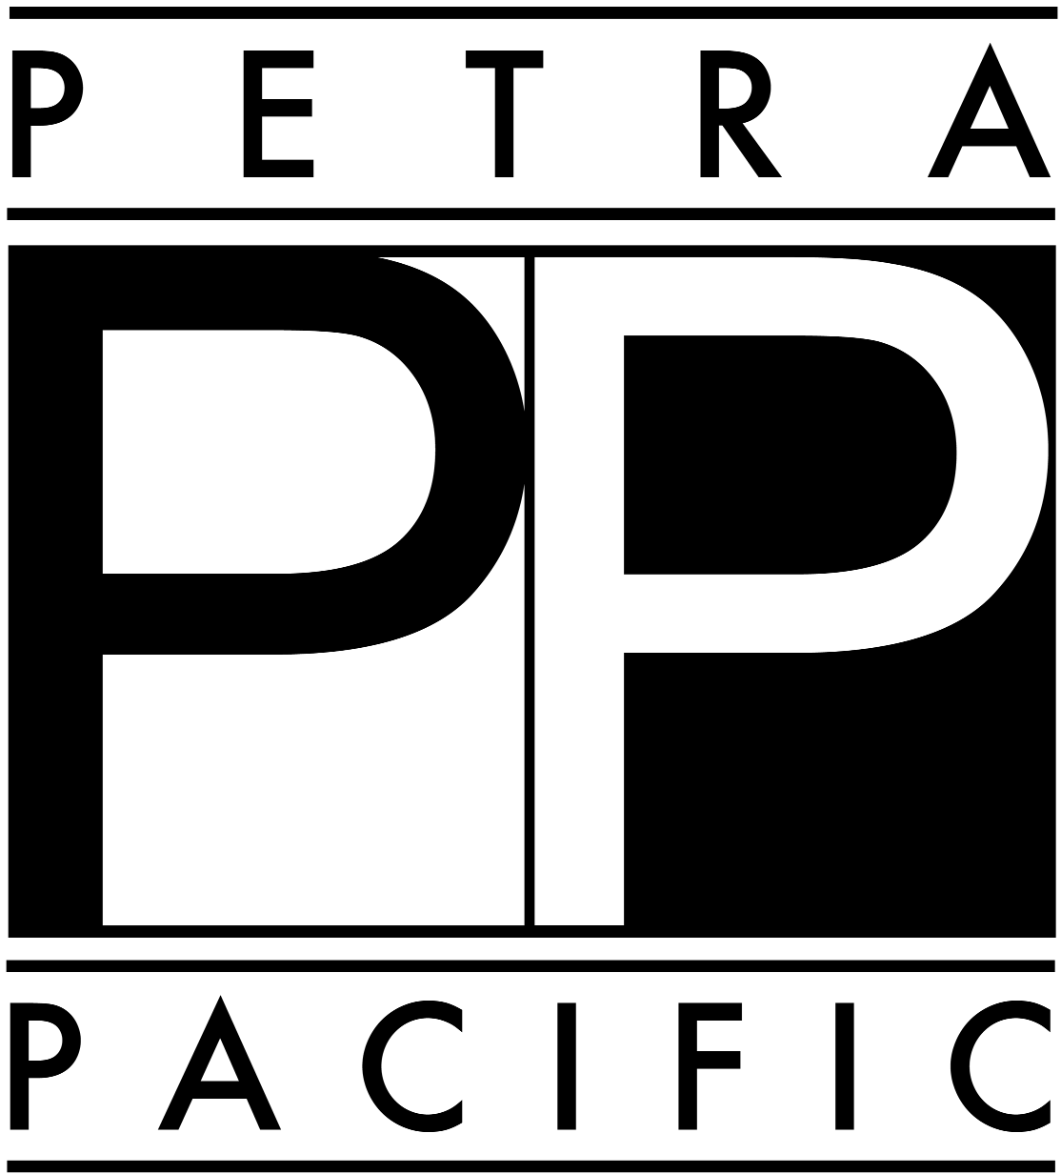

OSHA REQUIRED SAFETY

DOCUMENTS

- Injury Illness Prevention Plan
(IIPP)

- Bloodborne Pathogens Plan

- Hazard Communications Plan

- Lock-Out Tag-Out Plan

- Emergency Response Plan

- OSHA 300 Injury Log

- Written Safety Training Records

Petra Pacific Insurance Services
13950 Cerritos Corporate Drive, Cerritos, California (800) 466-8951
visit: petrariskmanagement.com

Major Points of an Injury Illness Prevention Plan (IIPP)

All employees should be aware of these IIPP points:

This business has a specific plan to prevent injury and work safely.

We implement this specific plan by doing the following:

- TRAINING: Our goal is to reduce, or eliminate unsafe acts that result in injury or damage. Training will be provided to meet this goal.

- COMMUNICATION: All occupational safety and health matters will be communicated with employees through written documents, staff meetings, training meetings, postings and MSDS.

- RESPONSIBILITY AND ACCOUNTABILITY: Employees are held accountable for safe work practices and to know and understand safety rules, policies and procedures.

- INSPECTIONS: Work areas will be regularly inspected and unsafe conditions corrected immediately. Monthly inspections of the entire property are also recommended and documented.

- ACCIDENT INVESTIGATION: All accidents that cause injury will be investigated. Corrective actions will be taken after the investigation which may include; additional training, repairing/replacing bad equipment or disciplinary action.

- RECORDKEEPING: This business will keep records of safety training, inspections and anything to do with employee health and safety.

- The IIPP has a List of Safe Practices that should be followed by all employees.

- All work related injuries shall be reported to a Supervisor immediately.

Major Points of a Hazard Communications Plan

- The goal of this Plan is to minimize the risk of Hazardous
materials or chemicals to our employees. This plan will provide employees with information about controlling exposures to hazardous materials.

- All containers with chemicals MUST be labeled with the name and hazard warning of the substance inside the container. This includes cleaning supplies, paint, lubricants, soaps, lotions etc.

- Chemicals are NEVER to be mixed together. This is a very important point that needs to be trained and communicated.

- Material Safety Data Sheets (MSDS): All chemicals stored or used at the business must have a MSDS sheet on file. The MSDS sheet will be in an area open to all employees. The MSDS sheets are provided by the chemical vendors. The MSDS book (s) should be reviewed and audited once a year to ensure all chemicals have a MSDS sheet in the book.

- TRAINING: All employees will receive training on:

  - Where hazardous materials are present
  - The physical and health effects of these materials
  - How to protect yourself, and prevent exposure
  - First Aid procedures for an exposure
  - How to use and read MSDS sheets
  - All employees shall receive annual training in Hazardous materials, MSDS, and the use of personal protective equipment

Major Points of a Lock-Out Tag-Out Plan

- The purpose of a Lock-Out Tag-Out procedure is to protect employees from accidental or unexpected activation of power equipment during repair, maintenance, cleaning, adjusting or servicing.

- Lock-Out Tag-Out is required if anyone removes a guard or safety device from a piece of power equipment, or if someone is required to place any part of his or her body into an area, on a piece of equipment or machine where work has to be done.

- All power sources for the equipment shall be turned off, and locked off so no one can turn the equipment on without approval.

- A procedure should be followed when preparing a piece of equipment for repair. Employees who work around the equipment shall be notified the equipment will be off and being worked on.

- Special locks and tags shall be used to lock off the equipments power source.

- All employees in the Business will be trained to recognize the special locks and tags used on equipment being repaired or serviced.

- Engineers or maintenance personnel will be the only employees in the Business that apply Lock-Out Tag-Out locks and tags. These personnel will be the only personnel that will remove the locks and tags.

- All employees shall receive annual training in Lock-Out Tag-Out procedures.

Major Points of a Bloodborne Pathogen Plan

- The purpose of this plan is to eliminate or minimize an employee’s exposure to bodily fluids that may contain disease or viruses.

- Blood and ALL bodily fluids are to be treated as Hazardous Materials.

- Employees shall use personal protective equipment, gloves, goggles or glasses, aprons, shields, special tools or cleaning supplies when they are dealing with bodily fluids.

- All contaminated items must be placed in RED BIOHAZARD bags or containers only.

- All hypodermic needles or other sharp objects that may contain bodily fluids must be placed in a hard Biohazard red container that seals shut.

- All contaminated items must be picked up (or shipped to) a company that specializes in the legal disposal of Hazardous Materials. Records of the pick up and legal disposal of the hazardous materials shall be kept.

- No hazardous materials, including bodily fluids, will be thrown away in the trash. All hazardous materials must be disposed of in a legal manner.

- All containers or objects that were contaminated by bodily fluids must decontaminated using appropriate cleaning materials.

- All employees who sort dirty laundry shall wear gloves while they are sorting.

- Personal Protective Equipment: gloves, goggles or glasses, aprons, shields, special tools or cleaning supplies shall be provided to the employees at no cost.

- Hepatitis B vaccinations shall be provided to all employees at no cost to them. If they choose not to get the vaccination, they will fill out a form included in this Plan.

- All exposure incidents shall be reported immediately. These incidents shall be investigated and documented

- All employees of the Business shall receive annual training on Bloodborne Pathogens. Additional training shall be provided on how to handle, clean and dispose of bodily fluids.

Major Points of an Emergency Response Plan

Types of Emergencies:
Fires Power Outage Death
Earthquake Police Action Flood
Robbery Civil Disturbance
Chemical Spills Bomb Threat

Initial Emergency Planning:

- Designate an Emergency Response Team
- Designate a Hotel Command Center
- Designate and train on an Evacuation Location for Employees and Guests
- Train Staff on Hotel Emergency Life Safety Systems
- Train on types of reports needed and how to complete an “Incident Log”
- Prepare Master Phone Lists for Management, Utilities, Police & Fire, Sewer, Shelter, Clean-up etc

Emergency Priorities:

- PEOPLE come first, make sure they are safe and provide medical treatment.
- PROPERTY comes second, protect the property from damage.
- PROTECT the Hotel from litigation.
- PRESERVE the Customer after the emergency is over.

All Employees should know:
- Where the Command Center of the Hotel is located
- What to do in the event of an Emergency
- Where to evacuate the employees and guests
- Have an Occupied Room list available
- Have a Handicapped Guest room list available
- Secure Banks, Cash Registers, Gift Shops, other valuables
- Where First Aid supplies are located
- Where extra Radios, Flashlights, Food and Water, Blankets are located
- Have Master Phone lists and copy of Emergency Response Manual available
- How to write an “Incident Log” to keep record of the incident and response
- How to operate the Hotel’s Life Safety Systems
- Be prepared for Media, have a plan to handle them

